Problem 1 [18 pts]:
For the five mechanisms shown below:
(a) Compute how many instant centers should there be in the mechanism.
(b) Identify all instant centers (ICs) for the mechanism using a linear graph to track them. Use the labeling convention from class to label each instant center, e.g., I₁₃. Show construction lines if needed (Rules 2,3,5).
Mechanisms 1-3 [3.5 pts each]. Mechanism 4 [5.5 pts]. Neatness and completeness [2 pts].
Mechanism 1
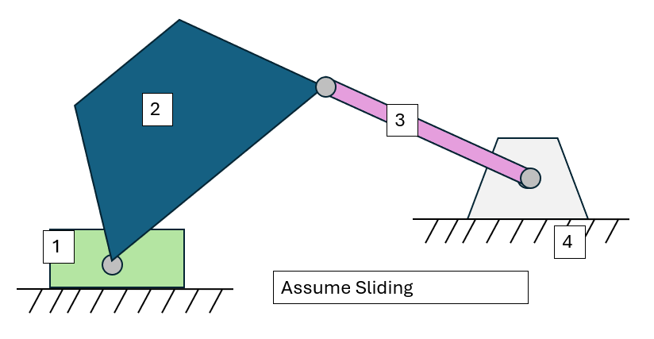
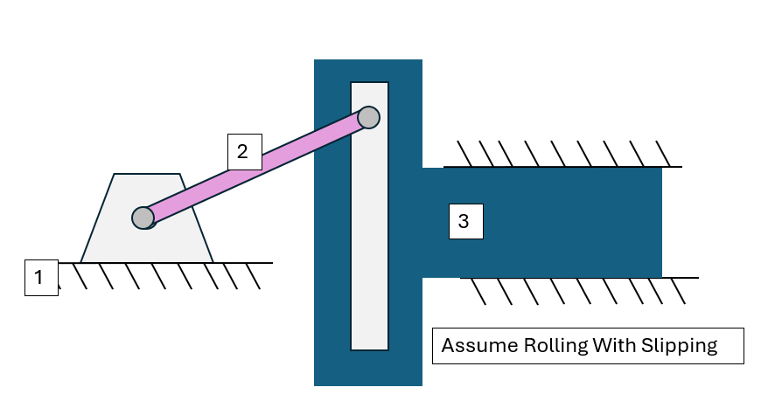
Mechanism 2
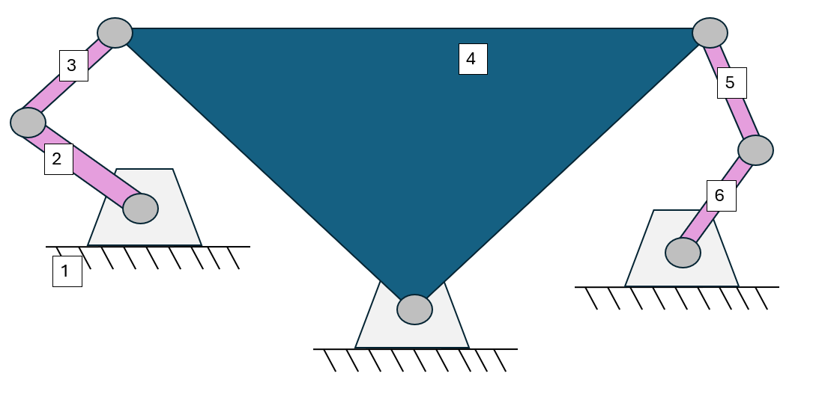
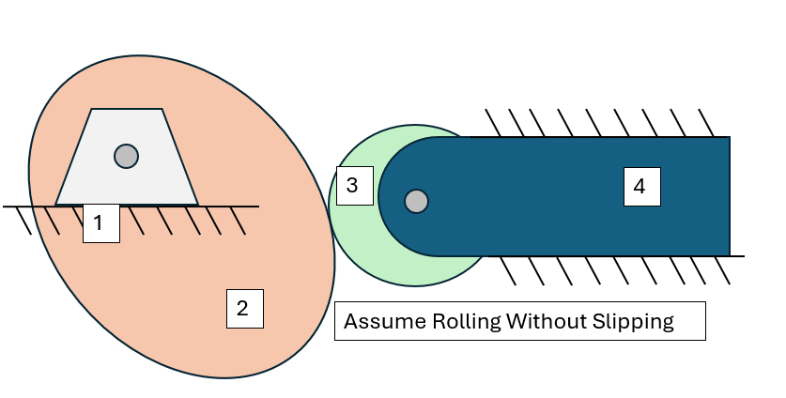
Mechanism 3
Mechanism 4

Problem 2 [12 pts]: Using Instant Centers
Consider the mechanism drawn below. The ultimate goal of this problem is to graphically illustrate and determine the magnitude and direction of the linear velocity at point C using instant centers. Assume that the input constant angular velocity ω₄ is known.
(a) Identify all instant centers for this mechanism. Follow steps (a) and (b) in Problem 1. [2 pts]
(b) Use geometry to draw $\overset{⃑}{V_{B}}$(velocity of point B) with its appropriate direction (make sure to indicate any known angles) and magnitude (length) in the figure. You can define the length of segments using |XY| notation, for the distance between points X and Y [3 pts].
(c) Write a symbolic equation to solve for the angular velocity of the link ABC (let’s call it ω₃) [2 pts].
(d) Does the angular velocity of link ABC differ with location on the link? Explain why. [1.5 pts]
(e) Define the magnitude and draw $\overset{⃑}{V_{c}}$(velocity of point C) with its appropriate direction in the figure. You must indicate the exact angle of this vector with respect to a known line (Hint: the line connecting to a particular instant center) [3.5 pts].
Show all work to reach your answers!
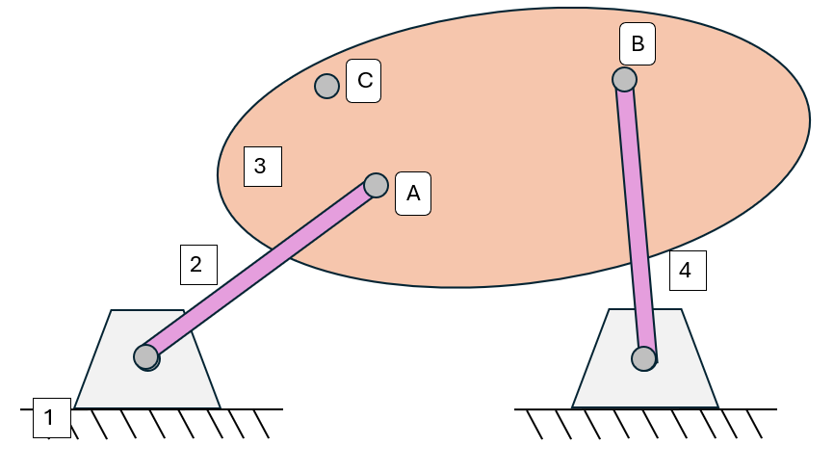
$$ω_{4}$$

Select one of the following options:
- My answer was created by a Gen AI algorithm, and I have not modified it
- My answer was created by a Gen AI algorithm, and I have made some minor changes.
- My answer was created by a Gen AI algorithm, and I have made major changes.
- My answer was created solely by myself.
- If I used Gen AI, I used ___ (name of program).

